Facilitator: Kanban Simulation Preparation

- There are sub-kits and posters inside of the box
- Do not open the sub-kits yet, place the sub-kits on tables in a layout similar to the “Sun Dot Manufacturing Company Room Set-Up.” Note that a larger paper of this diagram is also attached at the end of this document. Please set them up in order on a table from 1 to 9.

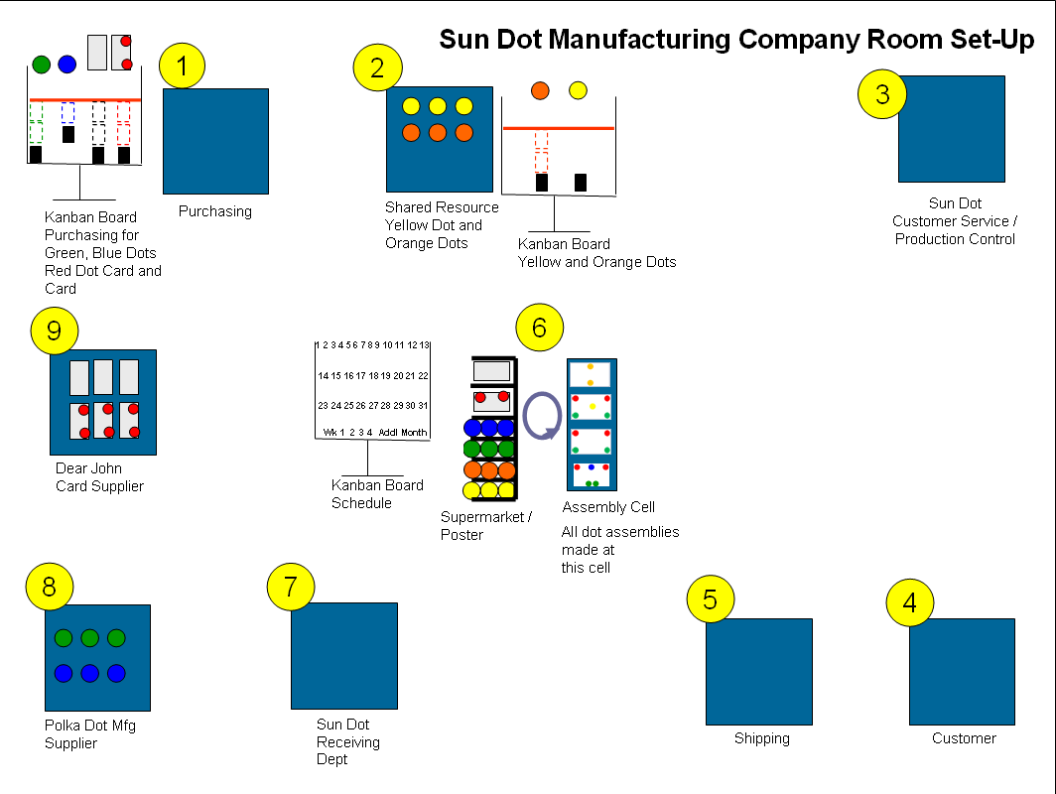

1. Purchasing
Set-up the raw materials on the table, place the purchase order cards onto the table (not taped down). Post the Kanban board (for blue dots, green dots, cards, and red dot cards) next to the purchasing table. See the picture below for the set-up:
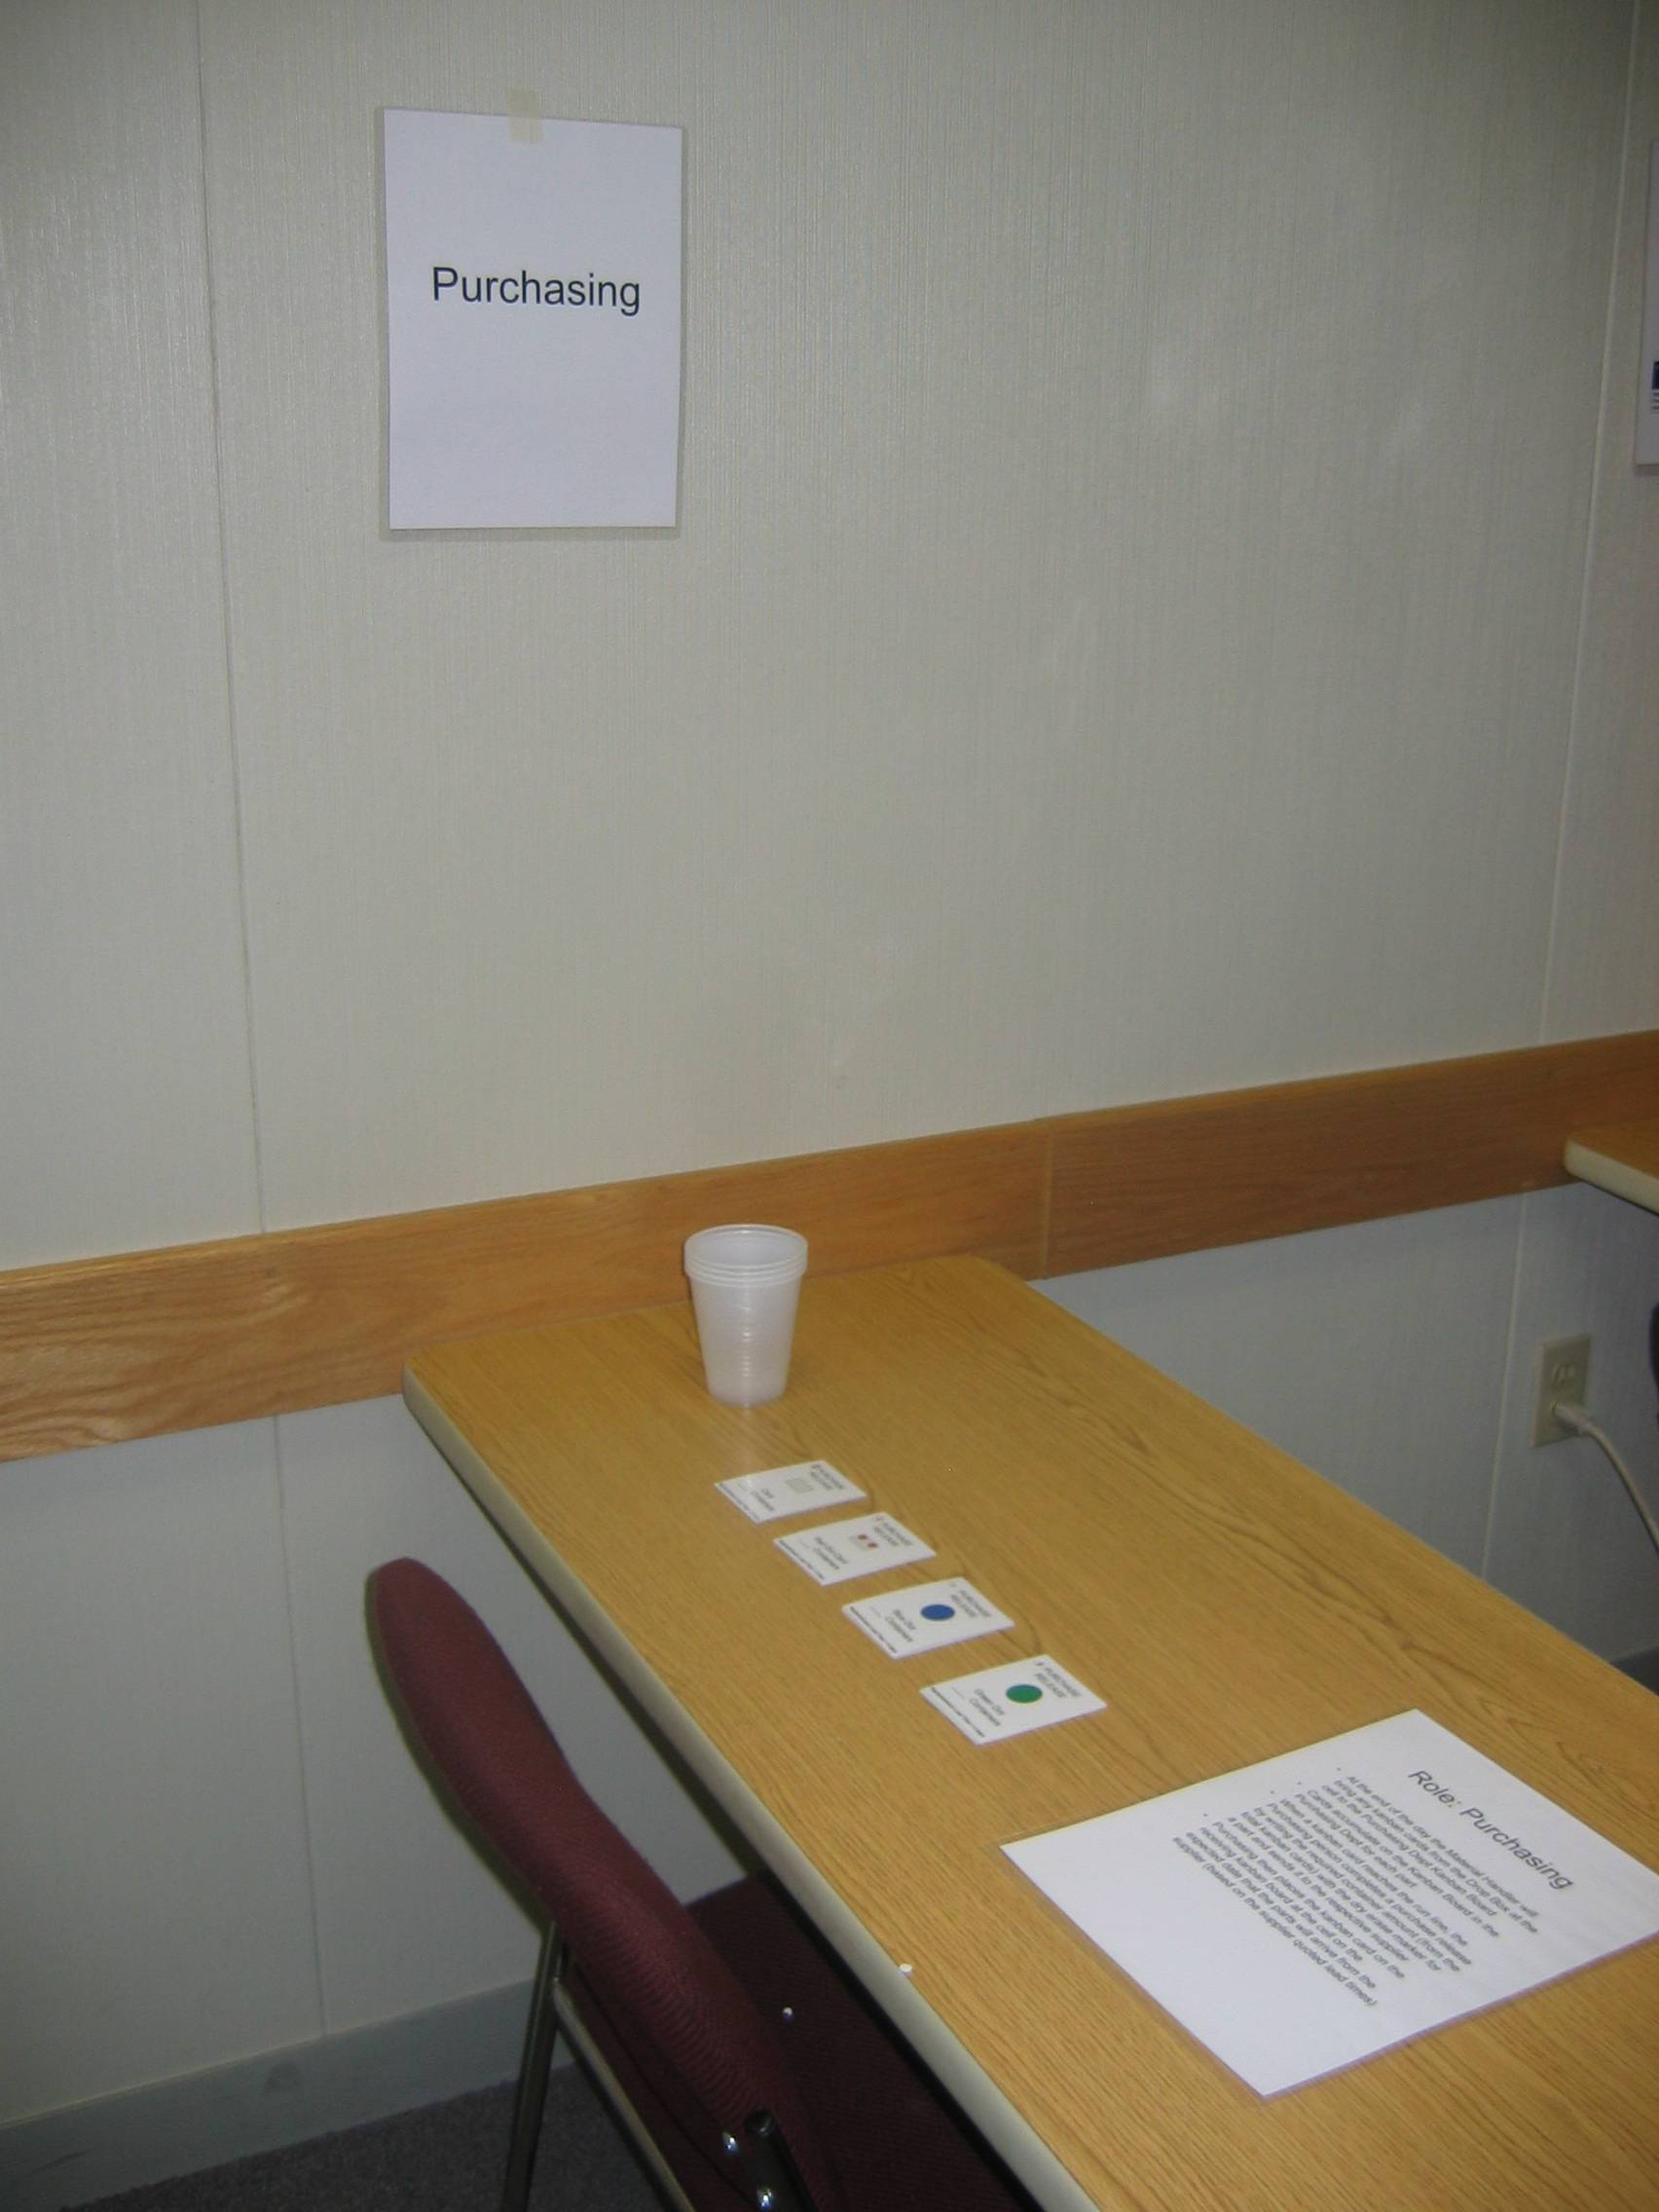
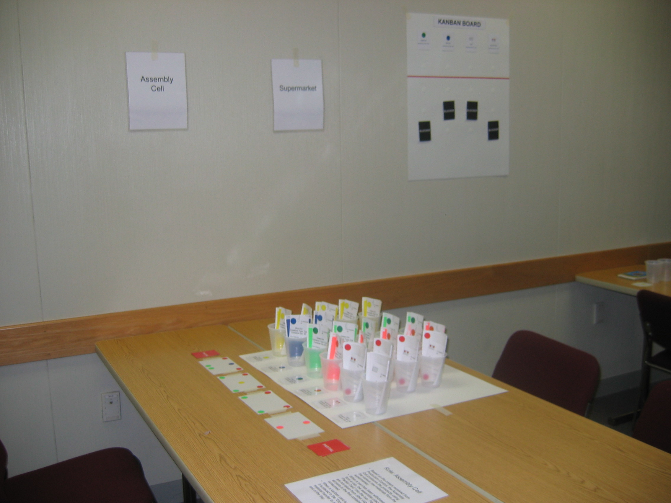
In this set-up:
(1) Purchasing sign
(1) Purchasing role playing standard work
(3) Purchase order cards for blue dots
(3) Purchase order cards for green dots
(3) Purchase order cards for cards
(3) Purchase order cards for red dot cards
(1) Black white-board marker
(1) Kanban board for blue dots, green dots, cards and red dot cards

2. Sun Dot Manufacturing Shared Resource
Set-up the raw materials on the table taping the product identification card onto the table. Post the Orange and Yellow Dot Kanban board near the Shared Resource table. See the picture below for the set-up:

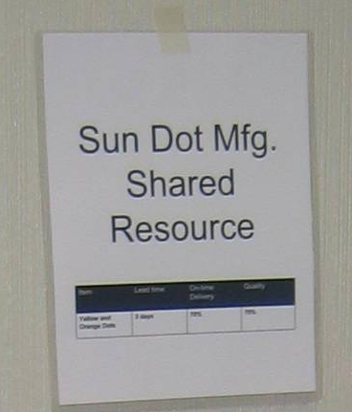
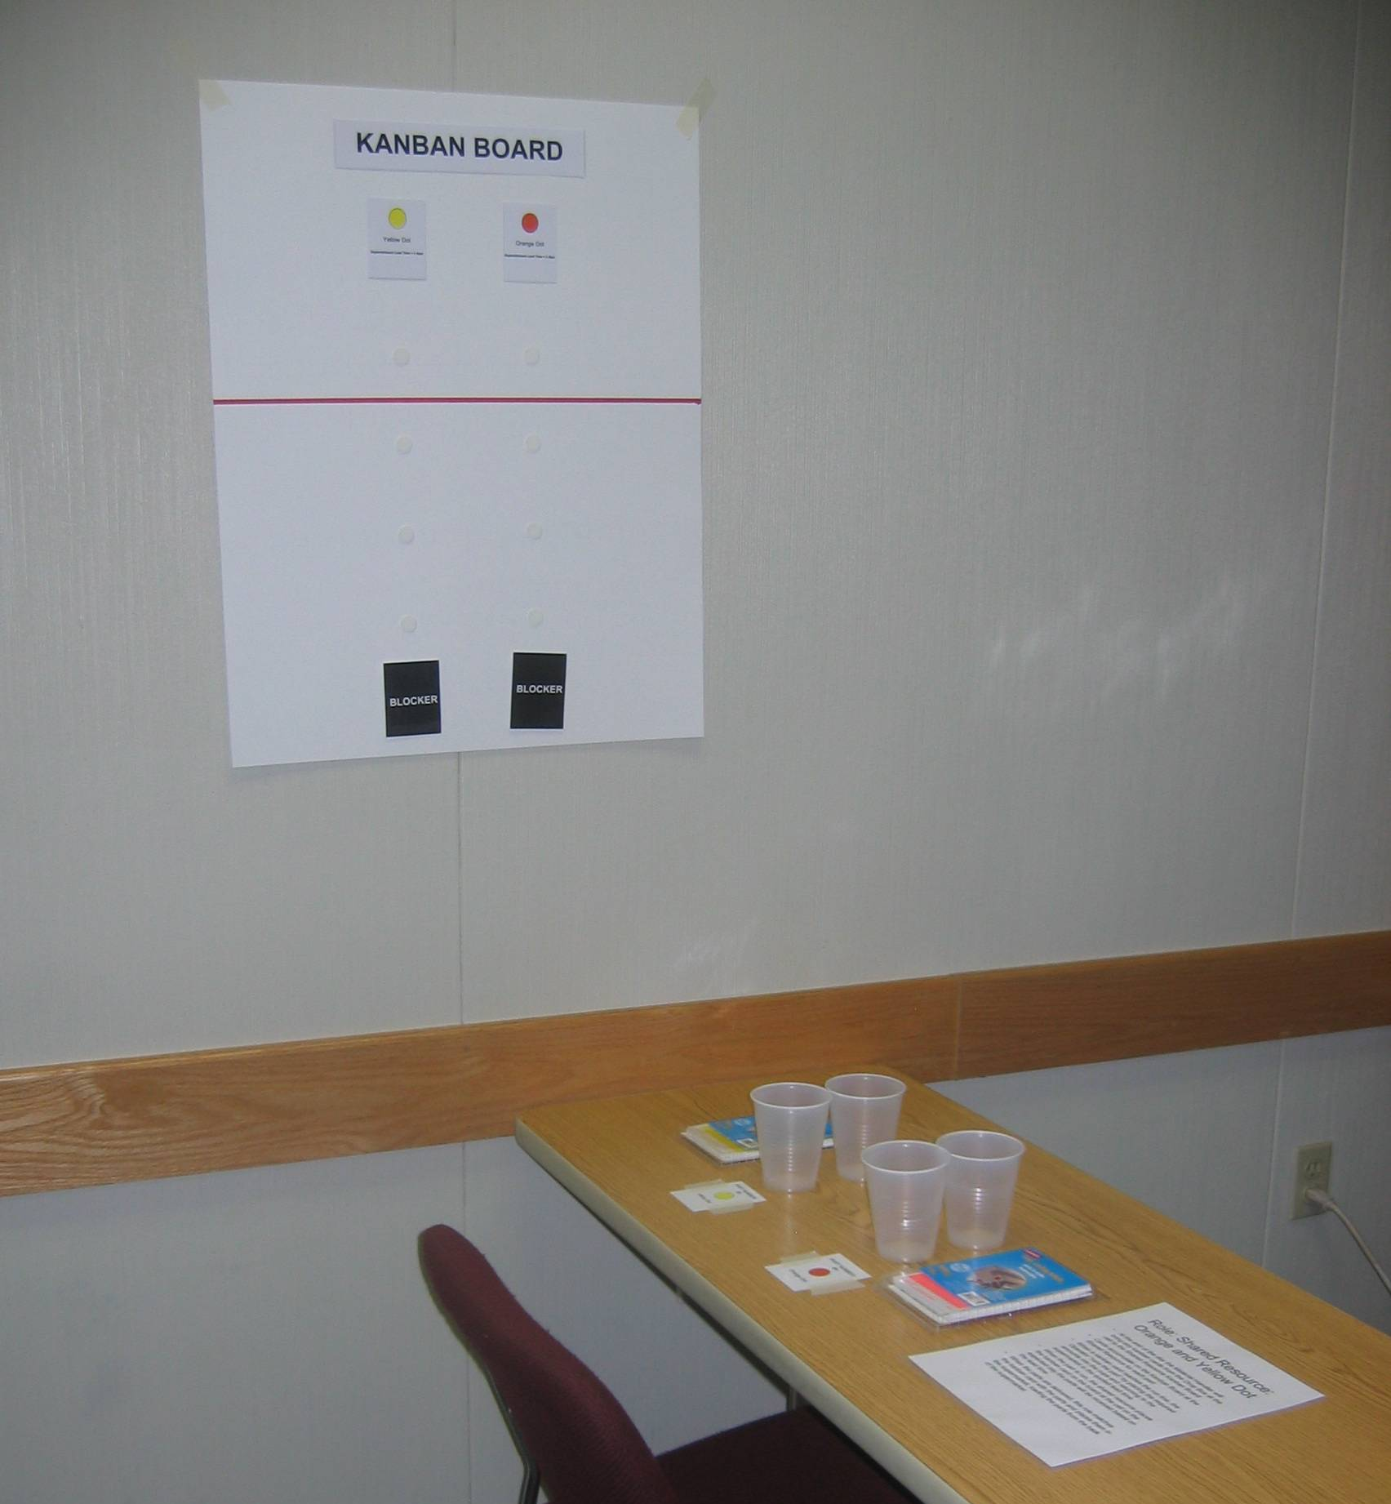
In this set-up:
(1) Sun Dot Manufacturing Shared Resource sign
(1) Shared Resource role playing standard work
(1) Yellow and Orange Dot Shared Resource Kanban Board
(1) Yellow Dots identification card
(1) Yellow Dots package
(1) Orange Dots identification card
(1) Orange Dots package
(2-4) cups

3. Sun Dot Production Control
Post the “Production Control” on the wall and place the role playing standard work on the table.

4. Customer
Post the “Customer” sign on the wall and place the role playing standard work on the table.

5. Shipping
Post the “Shipping” sign on the wall and place the role playing standard work on the table.

6. Supermarket and Assembly Cell
- Setting up the Supermarket and Assembly Cell: place the supermarket poster on a flat table setting up the products as shown in the picture:

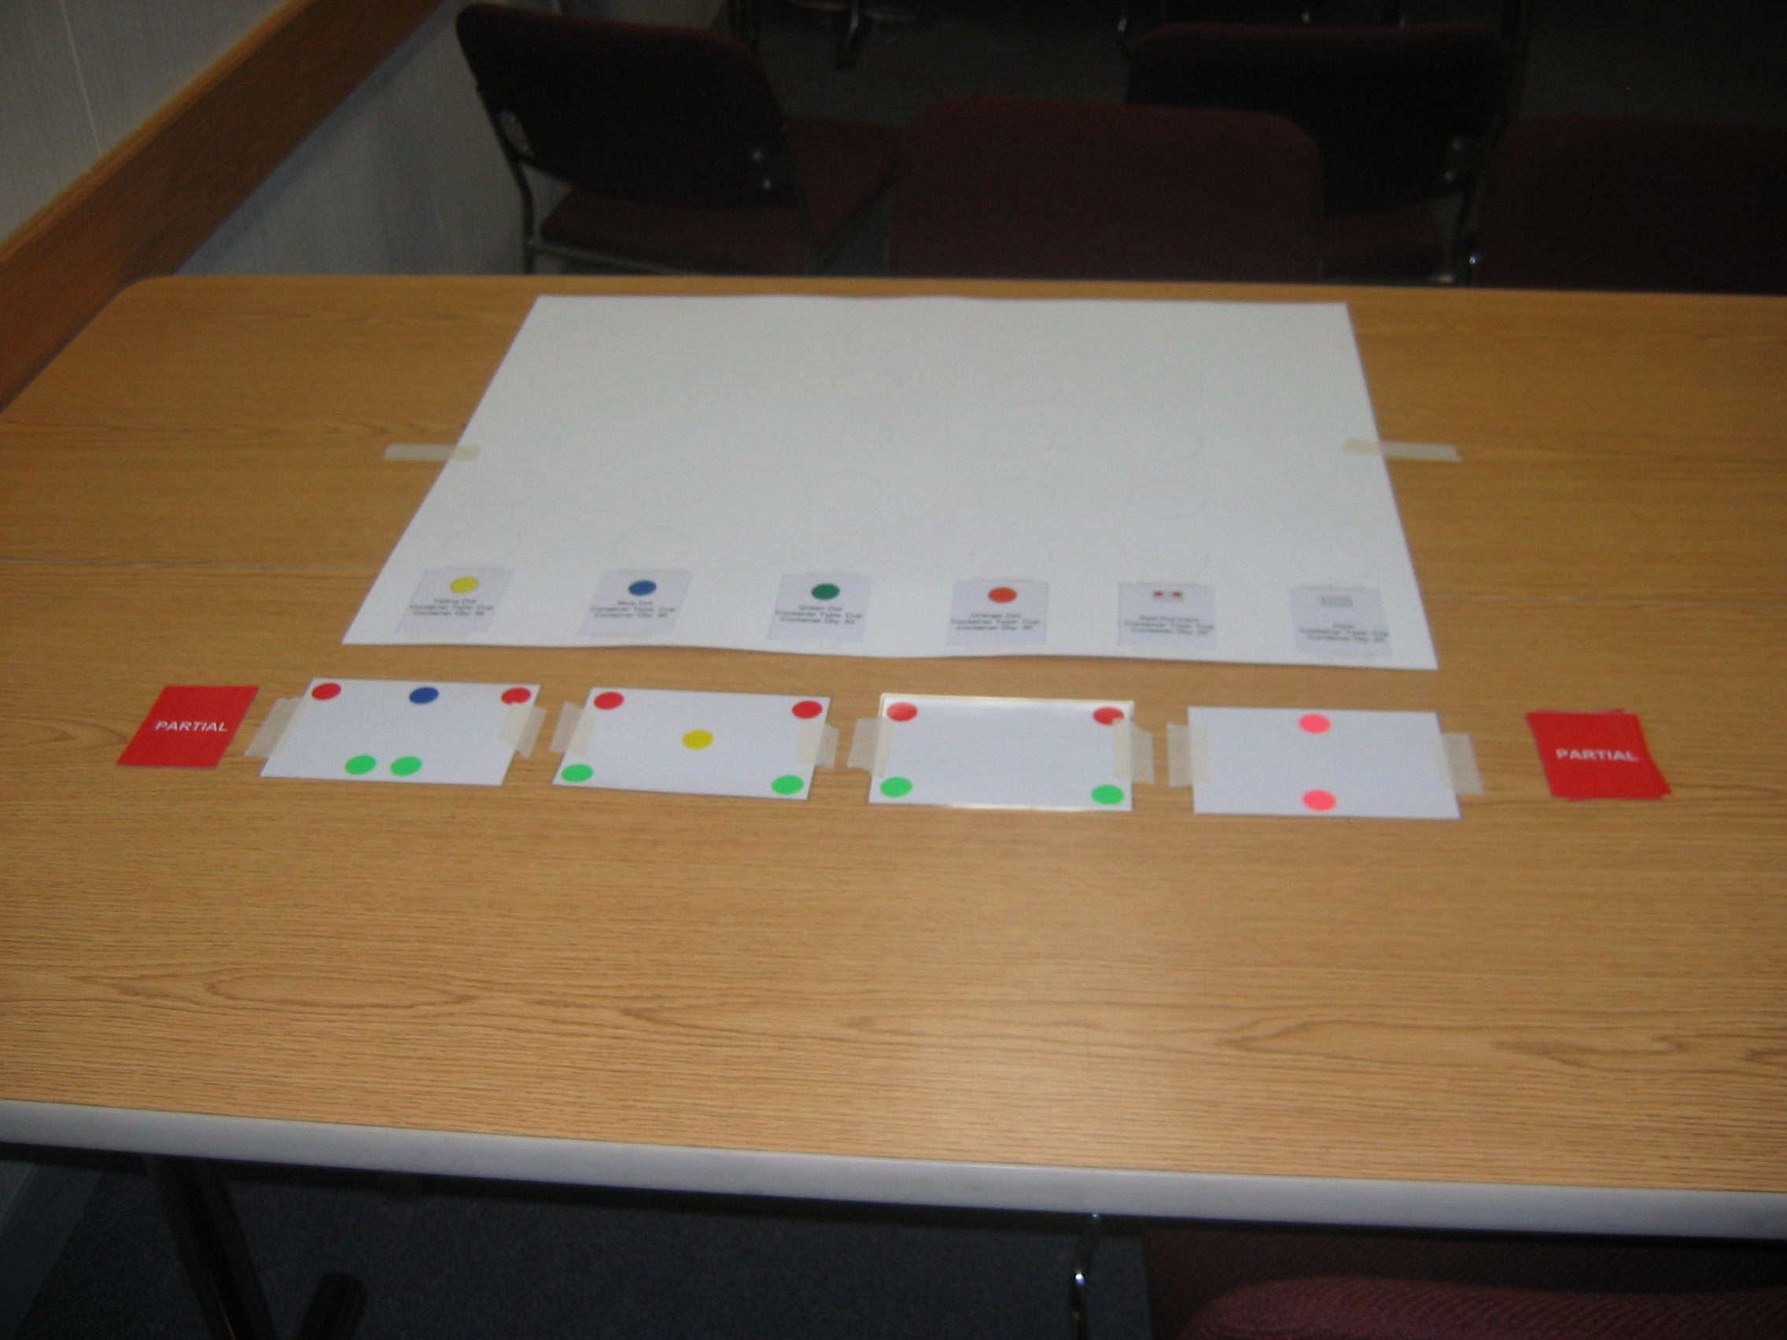
In this set-up:
(1) Supermarket Poster
(1) Sample of 2 X 2 X 1C
(1) Sample of 2 X 2
(1) Sample of 3 over 2
(1) Sample of 1 over 1
(6) Partial Cards
Note: tape down the poster and the 4 products onto the table so they don’t move around the table, and the partial cards are placed on the sides (3 cards for each side)

- Set the cups on the supermarket poster; match the number of cups onto the template (no tape necessary for the cups)

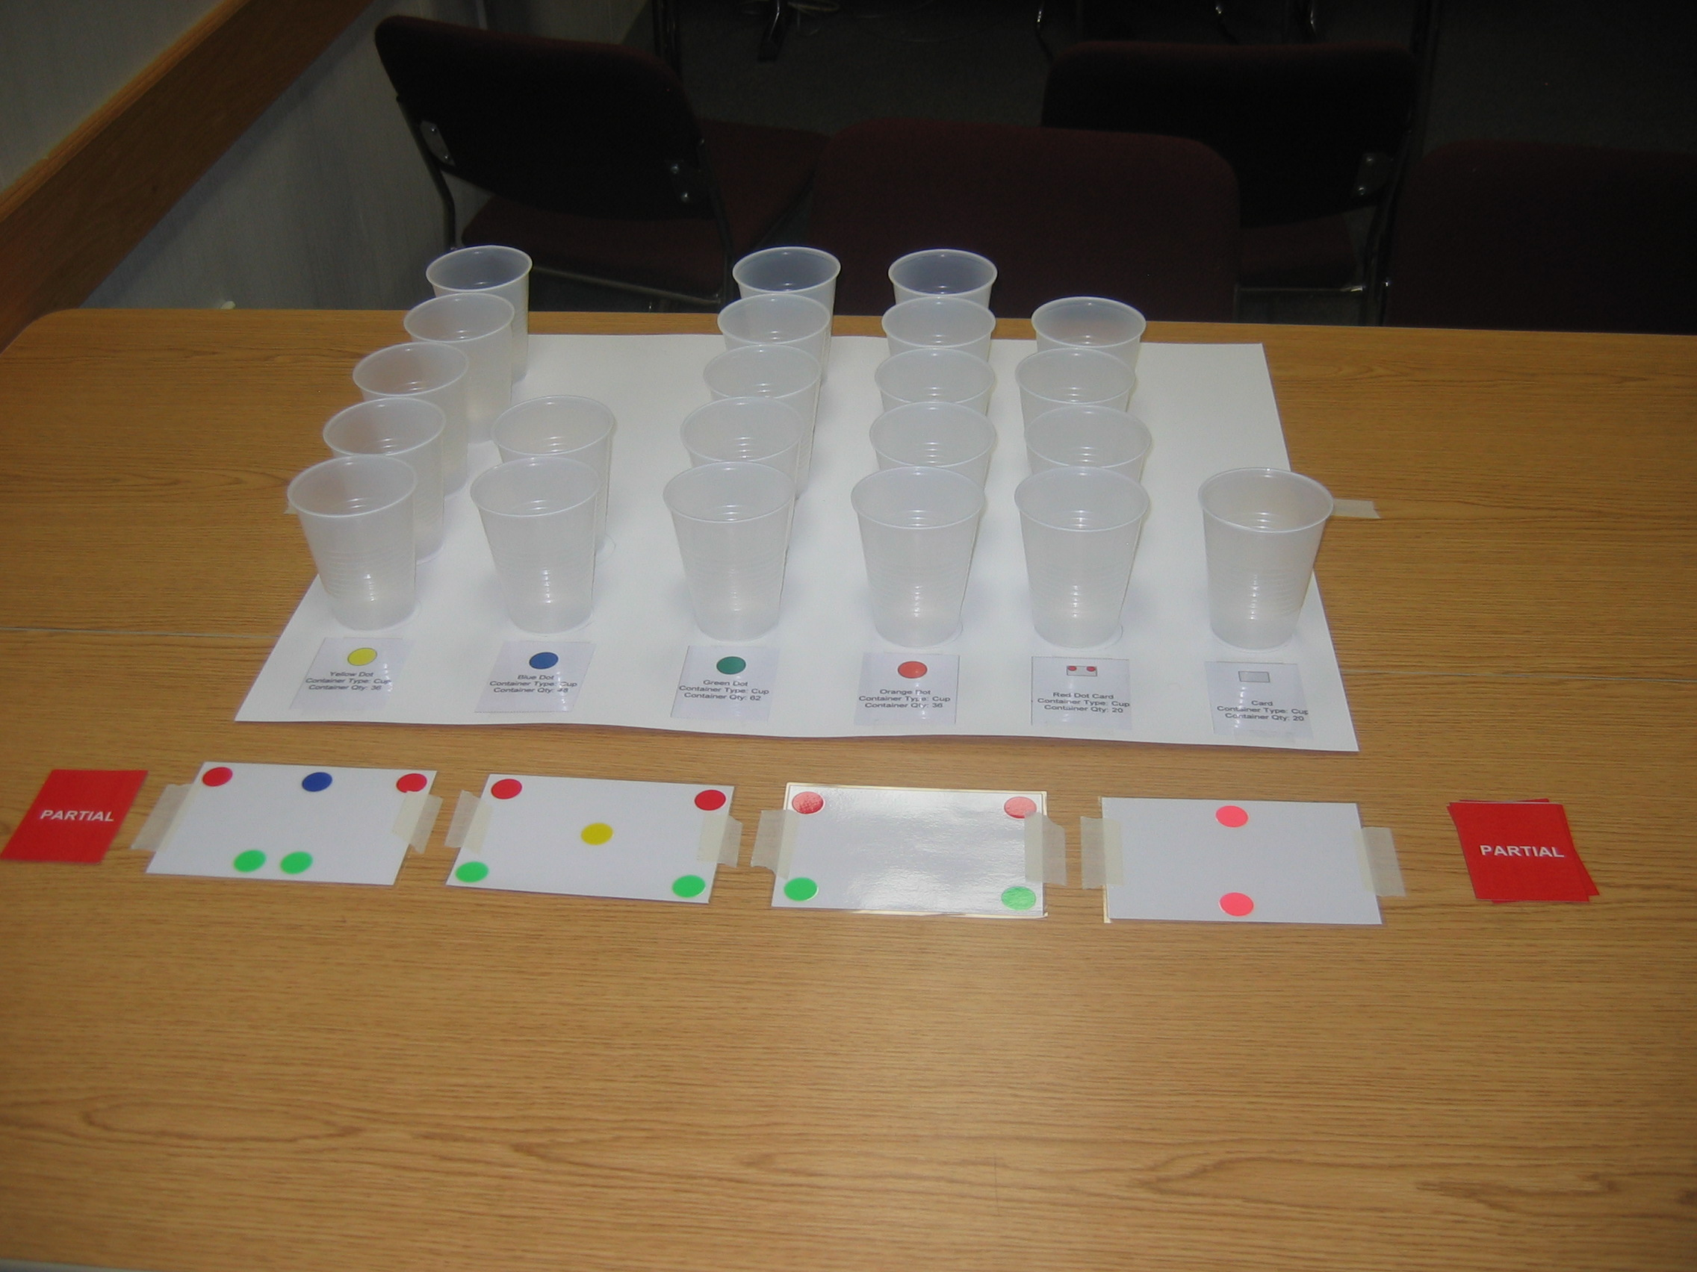
In this set-up:
(22) Cups

- Place the given raw materials packets in each of the cups. For the cards with more than one packet, you will need to place the first card in the front and place the second card behind the cup.
  - For example: Blue dot Card 1 of 2 inside a cup with the raw material is to be placed right behind the card labeled on the supermarket poster. Blue dot Card 2 of 2 is to be placed inside the cup behind Card 1 of 2 cup.

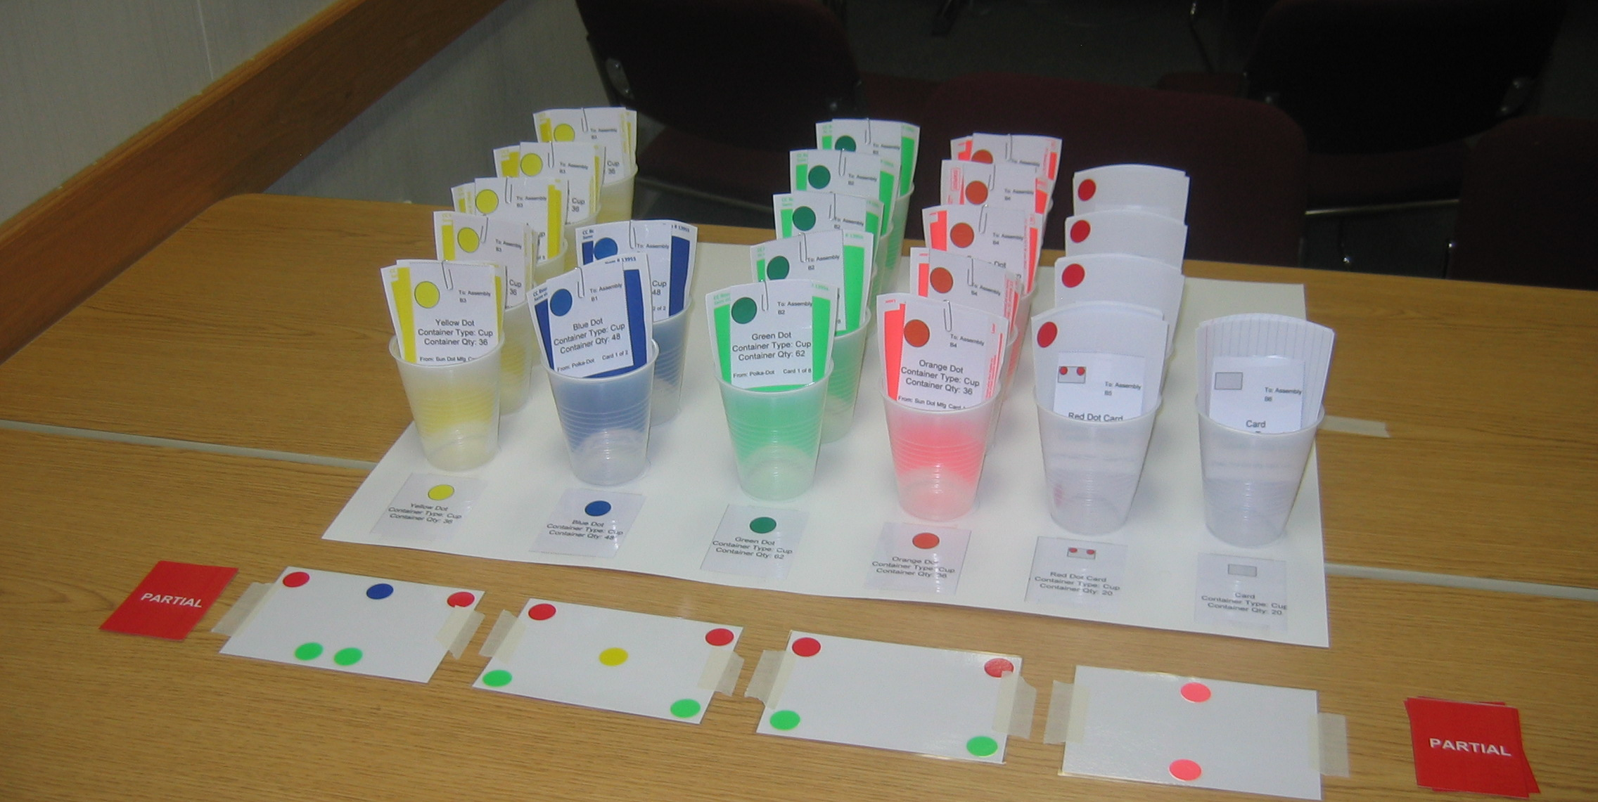
In this set-up:
(5) Yellow Dots Packets
(2) Blue Dots Packets
(5) Green Dots Packets
(5) Orange Dot Packets
(4) Red Dot Card Packets
(1) Card Packet

- Post the “Supermarket” and “Assembly Cell” signs on the wall so that the whole class can see what it is. Note: you can place the role of Assembly Cell next to the supermarket. Depending on the size of the class, the assembly cell can suit between 2-4 people for the assembly workers.
In this set-up:
(1) Assembly Cell Sign
(1) Supermarket Sign
(1) Assembly Cell Role playing standard work
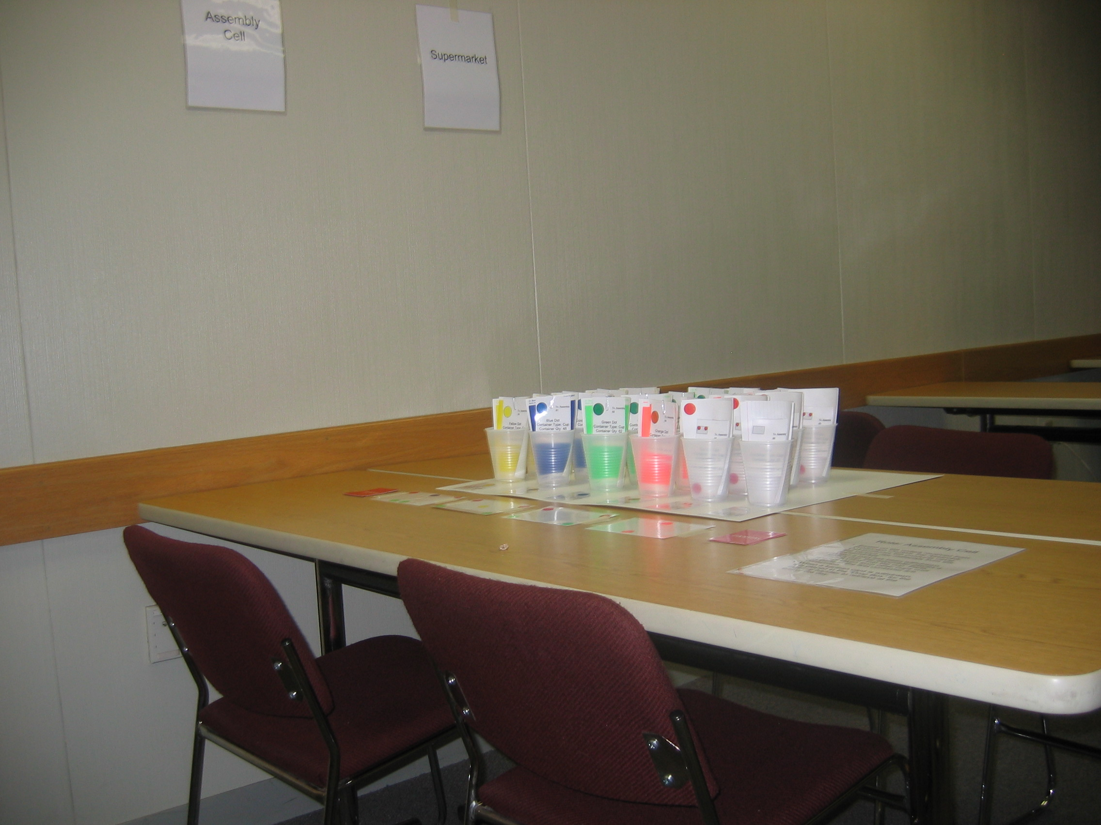

- The Kanban Board Schedule (with small hooks and numbers 1-31 posted) is suggested to be placed beside the supermarket where production control can see when the next purchased parts are coming in.

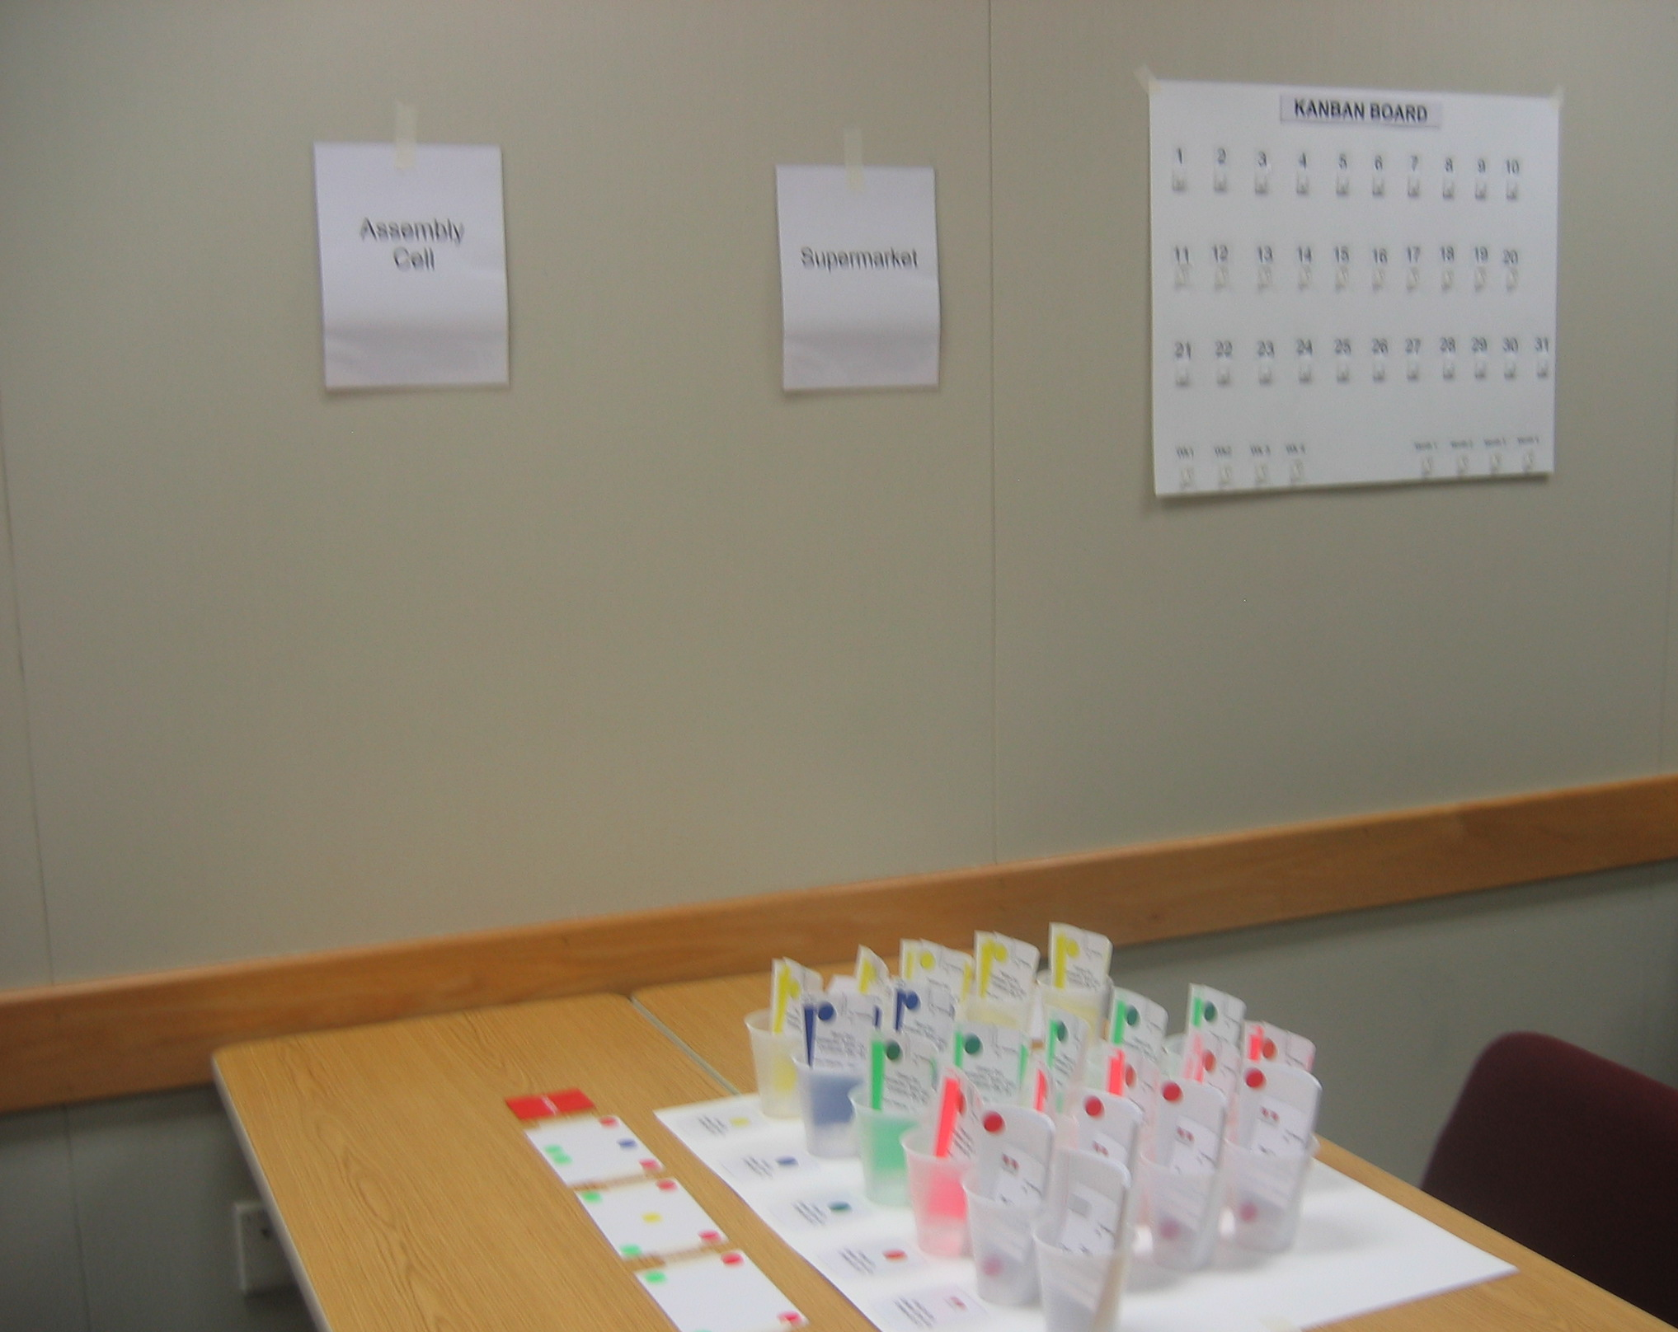
In this set-up:
(1) Kanban Board Schedule

7. Sun Dot Receiving Dept
Post the “Receiving” sign on the wall and place the role playing standard work on the table.

8. Polka-Dot Manufacturing Company
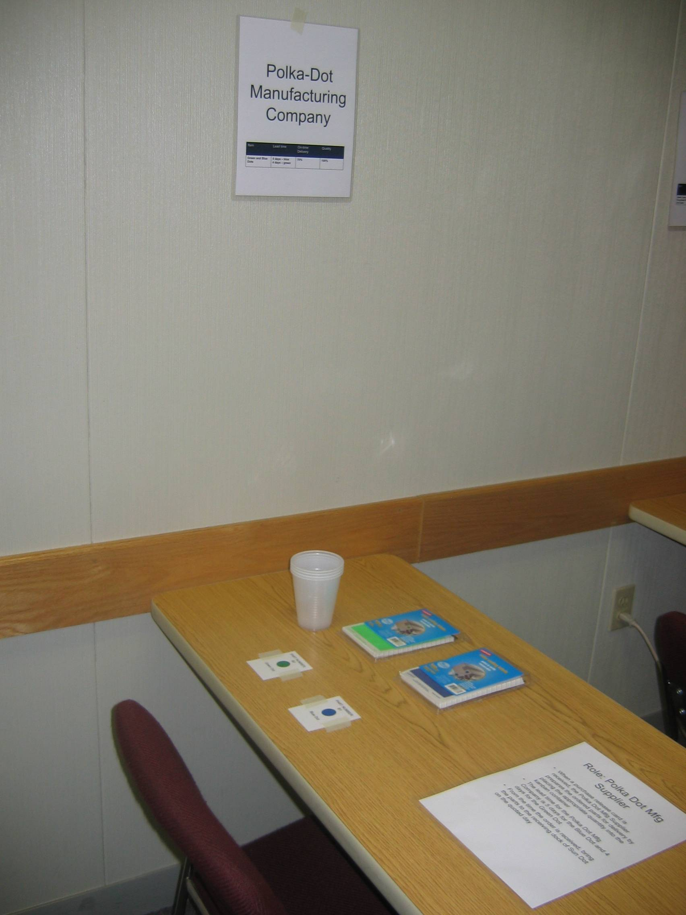
Polka-Dot Mfg Company: set-up the raw materials on the table, taping the product identification card onto the table. See the picture below for the set-up:

In this set-up:
(1) Polka-Dot Manufacturing Company sign
(1) Polka-Dot role playing standard work
(1) Blue Dots identification card
(1) Blue Dots package
(1) Green Dots identification card
(1) Green Dots package
(2-4) cups

9. Dear John Card Company
Dear John Card Company: set-up the raw materials on the table, taping the product identification card onto the table. See the picture below for the set-up:

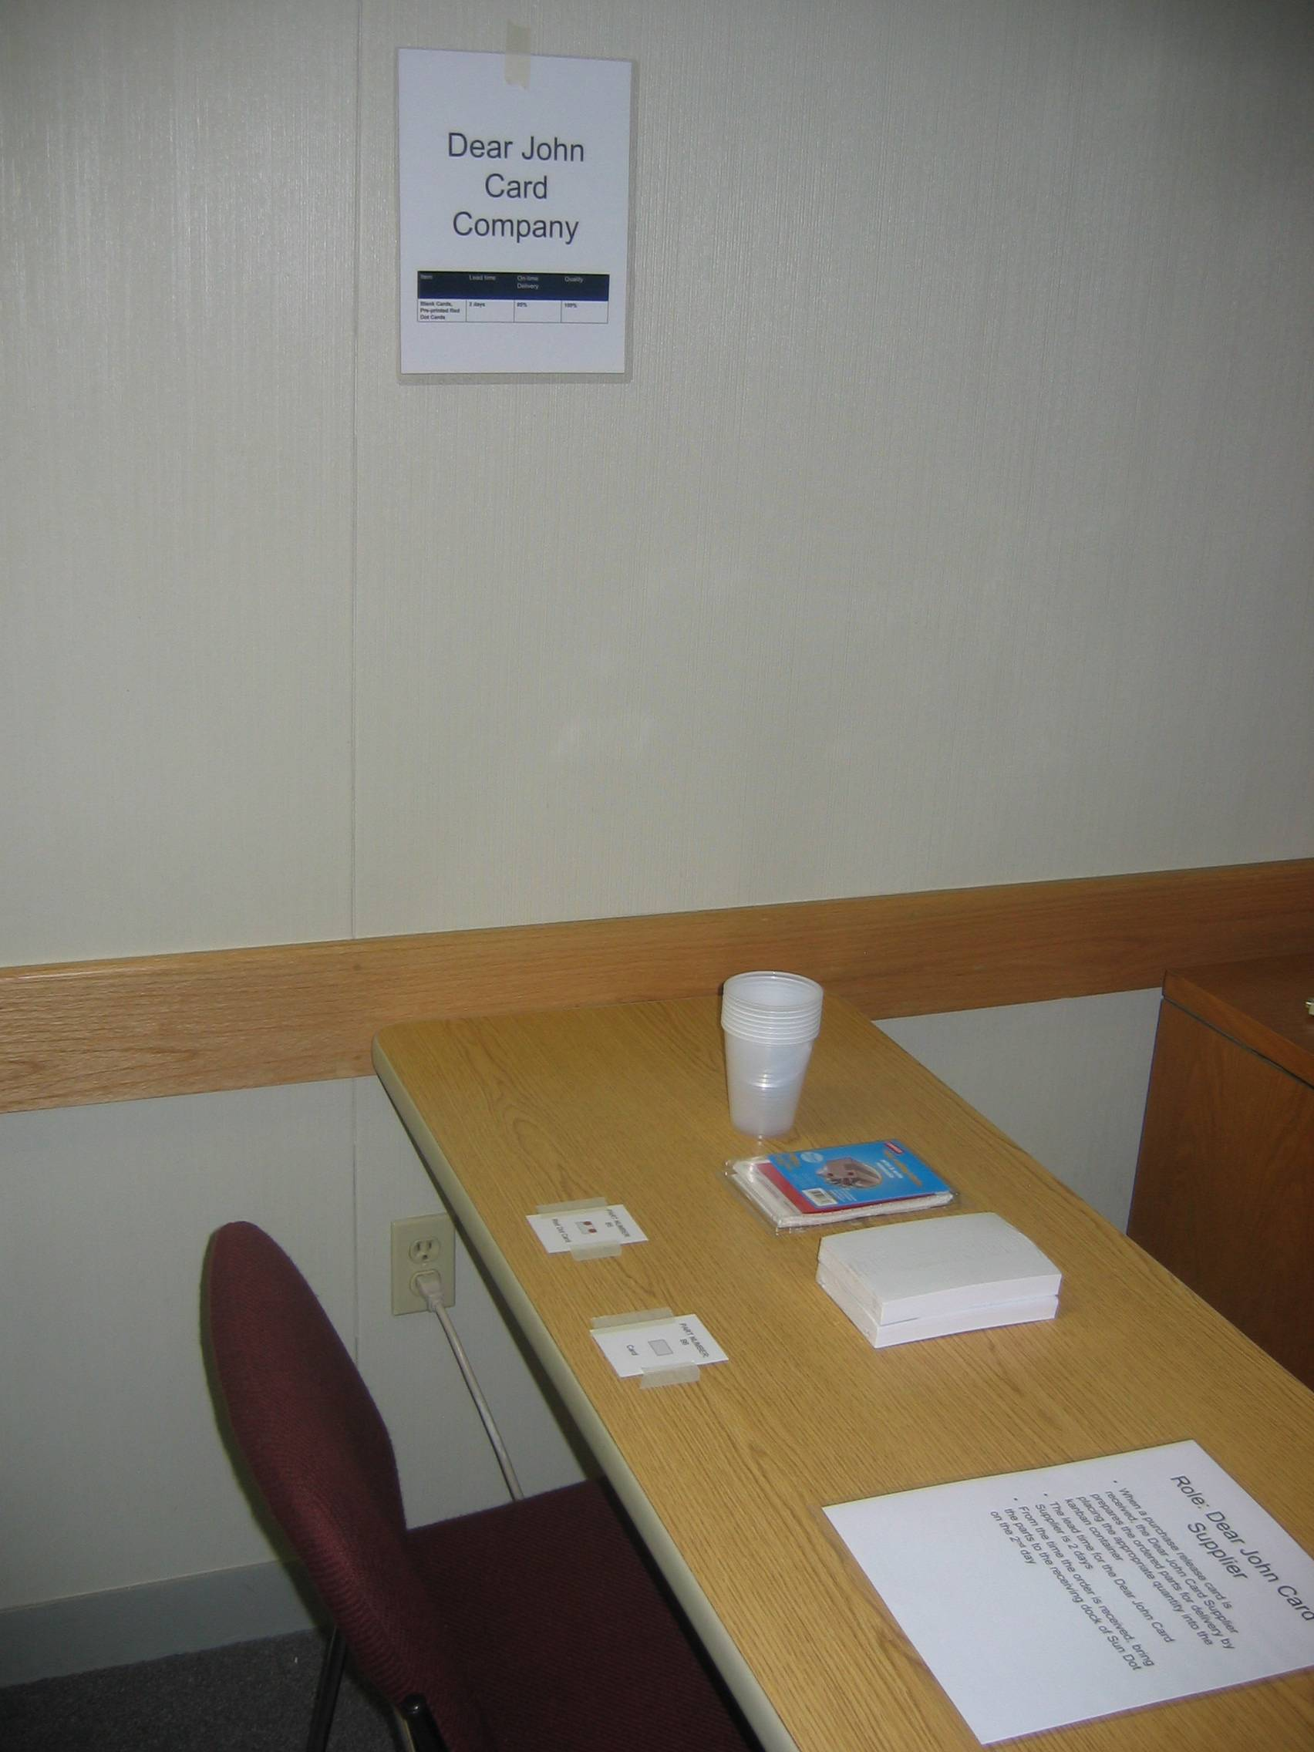
In this set-up:
(1) Dear John Card Company sign
(1) Red dot identification card
(1) Red dot package
(1) Card identification card
(1) Card package
(2-4) cups
(1) Dear John Card Company role playing standard work

NOTES:
Material Handler and Shift Supervisor roles do not have an assigned table. For these roles, assign a person for each role and have them to read their standard work out loud to the class when everyone is sharing their roles.

Review the Kanban Presentation for the simulation guidelines and standard work. Please run the simulation (flow of information) before the kanban event. Adjust the location of the layout so that it makes sense for the students to learn about how the kanban system works (with the provided layout). This will help you bring any questions you may have to the kanban resource team. Have fun!

